**Expert ID/Name: Nstructive**

**Date: 09-Nov-2020**

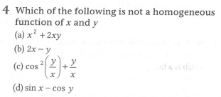

**Answer:**

|  |
| --- |
| MCQ Type Answers |
| Choices |

|  |
| --- |
| Tip:  *The function* is a homogeneous function then. |

|  |  |  |  |  |  |  |  |  |  |  |  |  |  |  |  |  |
| --- | --- | --- | --- | --- | --- | --- | --- | --- | --- | --- | --- | --- | --- | --- | --- | --- |
| Correct Answer: (d)  Explanation:   |  |  | | --- | --- | | Instruction | Write. | | Calculation | So it is not a homogeneous function. |   Incorrect answer (a)  Explanation:   |  |  | | --- | --- | | Instruction | Write. | | Calculation | So, it is a homogeneous function . |   Incorrect answer (b)  Explanation:   |  |  | | --- | --- | | Instruction | Write. | | Calculation | So, it is a homogeneous function |   Incorrect answer (c)  Explanation:   |  |  | | --- | --- | | Instruction | Write. | | Calculation | So, it is a homogeneous function | |

|  |
| --- |
| Final answer: Option (d) is correct answer. |